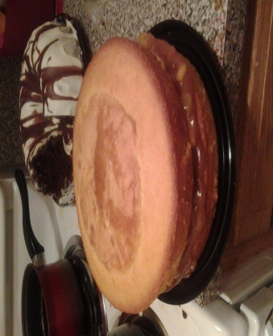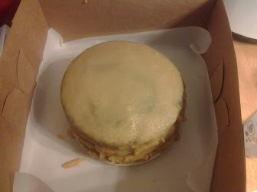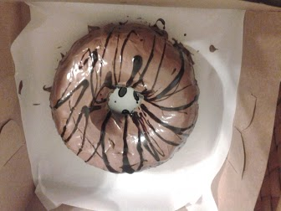
2 & 3 Layer Round & Bundt- Great for Small get-togethers or as a gift
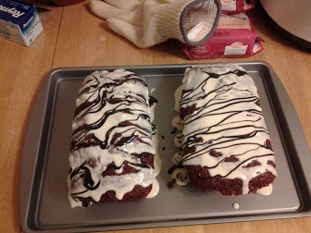
Mini Loaf- Perfect for a personal treat when you don’t want to share….
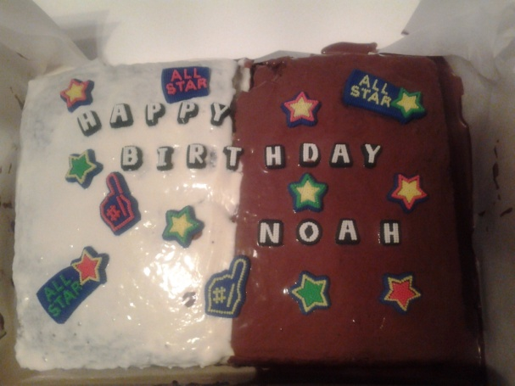
2 Layer Long- The perfect size for a birthday party or go a size up (2LLFS) for a larger get together!
Find us on Facebook @ Baba’z Kitchen! Order today!
Name:
Best Contact Number:
Dessert Choice(s):

Size & Quantity:

Special Request(s)/ Instruction(s):

Dessert Date:

Delivery/Pickup:
Address (Delivery):

Date Ordered:
Amount Due:

