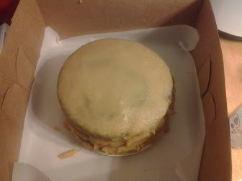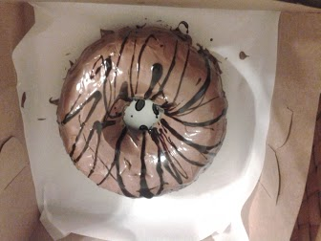
2 & 3 Layer Round & Bundt- Great for Small get-togethers or as a gift
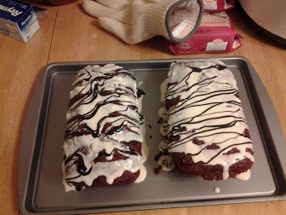
Mini Loaf- Perfect for a personal treat when you don’t want to share….
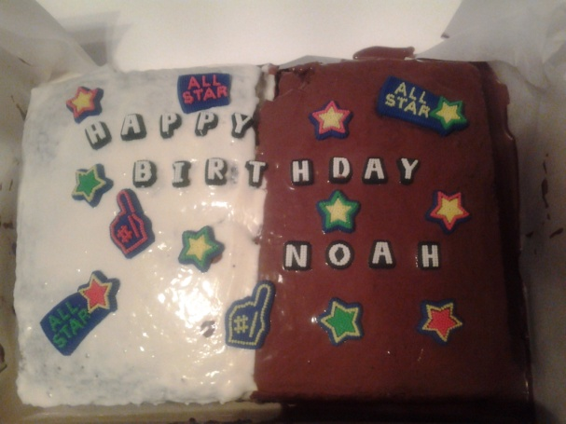
2 Layer Long- The perfect size for a birthday party or go a size up (2LLFS) for a larger get together!
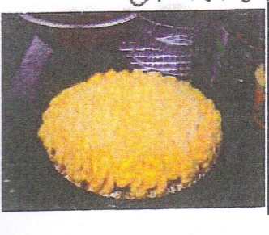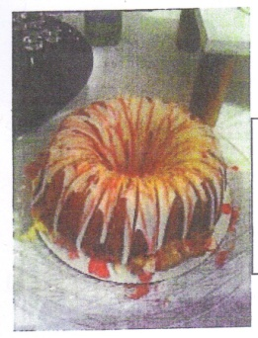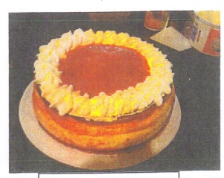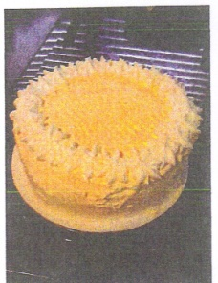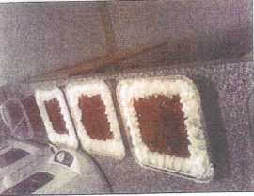
Cheesecake(s)-Many different forms, toppings, & options
Cakes* | Muffins* | Brownies & More
Caramel Cake | Banana Nut | Cocoa Marble Gingerbread*
Carrot Cake | Blueberry | Apple Pie Chocolate Brownie Cake*
Old-Fashioned Chocolate Cake | Blueberry Cheesecake | Peppermint Pattie Fudge Bars*
HERSHEY'S Red Velvet Cake | Chocolate Chip | Ultimate Chocolate Brownies*
Spice | Chocolate Chocolate Chip | Rum Babas
Fudge | Strawberry | Cinnamon Chip Applesauce Coffee Cake*
 | Wildberry | Berry Loaf*
Cookies | Lemon Poppy Seed | Cheery Cranberry Chocolate Chip Bread*
Chocolate Chip | Apple Cinnamon
Gingerbread |  | Vegan Desserts
Oatmeal | Cheesecakes | Cupcakes
Oatmeal Chocolate Chip | Baked | Sweet Sticky Rice w/Mangoes
Peanut Butter | No-Bake | Peanut Butter Fudge
Pumpkin Spice | Best of Both Worlds | Chocolate Cake
Sugar | Closed Top | Brownies
 | Open Top | Carrot Cake
 | 3 Amigos | Chocolate Oatmeal Cookies
 | Bundt Cake | Strawberry Pie
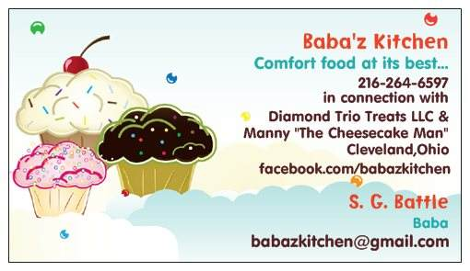  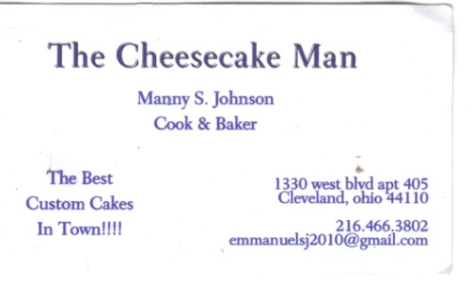 |  | Deep-Fried Sweet Potato Balls
 |  | Gingerbread Cake
 |  | Golden Yam Brownies
 |  | Cheesecake
 |  | Rum & Chocolate Cheesecake

